INSTRUCTIONS FOR SUBMISSION

- Participants are to complete all sections using black Calibri font size 12. Incomplete forms will not be accepted.

- Citations should be included where necessary and they are not included in the word count. Participants should fill in their references and other forms of acknowledgment in Section C.

- Participants are to submit this write up in an editable Word Document format.

- Submission file name taxonomy:
BDGC2025_TeamName (e.g. BDGC2025_GeospatialChallengers)

JUDGING CRITERIA
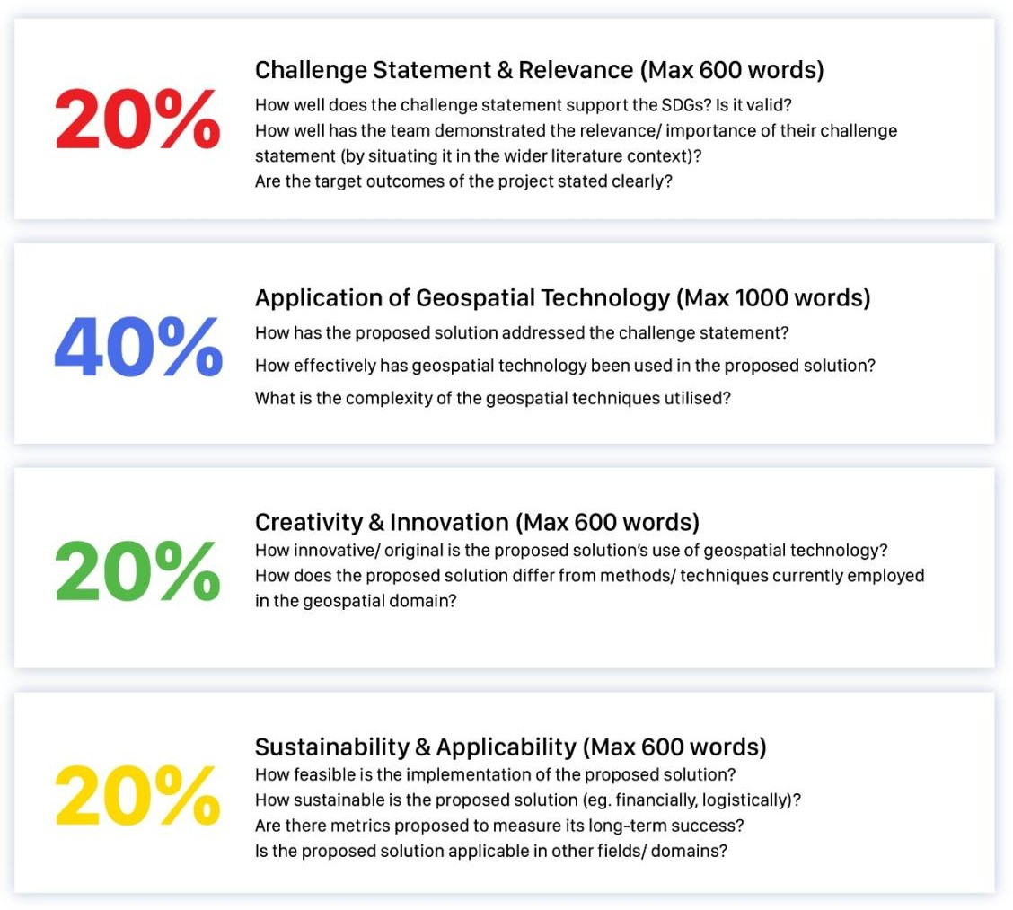

Section A: Team Composition
Team Name

Participants are to provide their full name as per their relevant identification documents.
Name | Name of Educational Institution | Email Address
(Student Representative)
(Team Member)
(Team Member)
(Team Member)

Section B: Project Details
Project Title
Summary of Project
(Explain, in less than 150 words, what the project is about.)

Participants are to fill in their word count for each criterion.
Criterion 1: Challenge Statement & Relevance (20%)
Max 600 words | Actual count: |  | words

Criterion 2: Application of Geospatial Technology (40%)
Max 1000 words | Actual count: |  | words

Criterion 3: Creativity & Innovation (20%)
Max 600 words | Actual count: |  | words

Criterion 4: Sustainability & Applicability (20%)
Max 600 words | Actual count: |  | words

Section C: References
Participants should clearly state their references and other forms of acknowledgement in this section here.

